APPROVALS

HISTORY OF CHANGES

Revision | Authored/ Revised by | Section # Changed | Summary of the Changes | Reason for the Change | Issue Date (YYYY MM DD)
0 | Echo Lu |  | Initial release of C-0003229, Supplier Shipment Label Requirement |  | 2022-07-22

- purpose
This document specifies supplier labeling requirement for components, sub-assemblies and assembled products. Label format other than what is described within this document can be used, as long as they convey the required information.
- scope
This Specification is applicable to box/pallet packaging of all components supplied to Creation Technologies, which purchased from supplier, vendors or manufacturers. These products include, but not limited to components, sub-assemblies and final assemblies.
- Category of this Document
N/A
- DEFInITIONS
Supplier – any organization that supplies part(s), (non-)production or logistic service(s), including engineering, tooling, calibration, contractors, consultants.
- Functions Responsible for this PROCEDUre
The functions listed below have responsibilities detailed in this procedure:
- Procedure Owner: [Supplier Quality Director—HQ Quality]
- Procedure User: [Supplier Chain, Supplier]
  - Supply Chain is responsible for communicating the requirements to the supplier.
  - Supplier is responsible for complying with the requirements of this document.
- Contributors: [Incoming Receiving, Supplier Chain]
  - Incoming Receiving/Supplier Chain feedback required component labels meet or exceed this requirement.

- TRAINING
The owner and the author of the procedure are considered trained by default because of their contribution in writing and reviewing/approving the document.
Trainer: Document author is the prime trainer or they may assign this role to other functions
The procedure users must be trained per the following training plan
Example: [Change as applicable]
For the first time release of the procedure: All users will be trained in-person or on-line and complete a quiz through training database. The result of the completed quiz will become the training record.
The contributors to the procedure per the Responsibility section do not require formal training. The users must inform the contributor of the requirement when they are engaged in their contribution for the procedure
Condition | Training for procedure user | Training documentation
First time release of the QMS document or SOP | In-person/On-line training for the entire procedure

- equipment/materials/supplies
NA
- procedure
  - Label Characteristics
The label shall be white and printed in black ink, does not prevent recyclability of the package to which the label is attached.
  - Items shown on below format should be applied to shipment label. Apply Creation Customer Part Number and Special Instruction if applicable.
- Creation Customer Part Number (if applicable), this PN is used for Creation’s customer, it is not mandatory, it is optional. Suppliers need to apply Creation’s CPN if customer required.
- Special Instruction (if applicable)
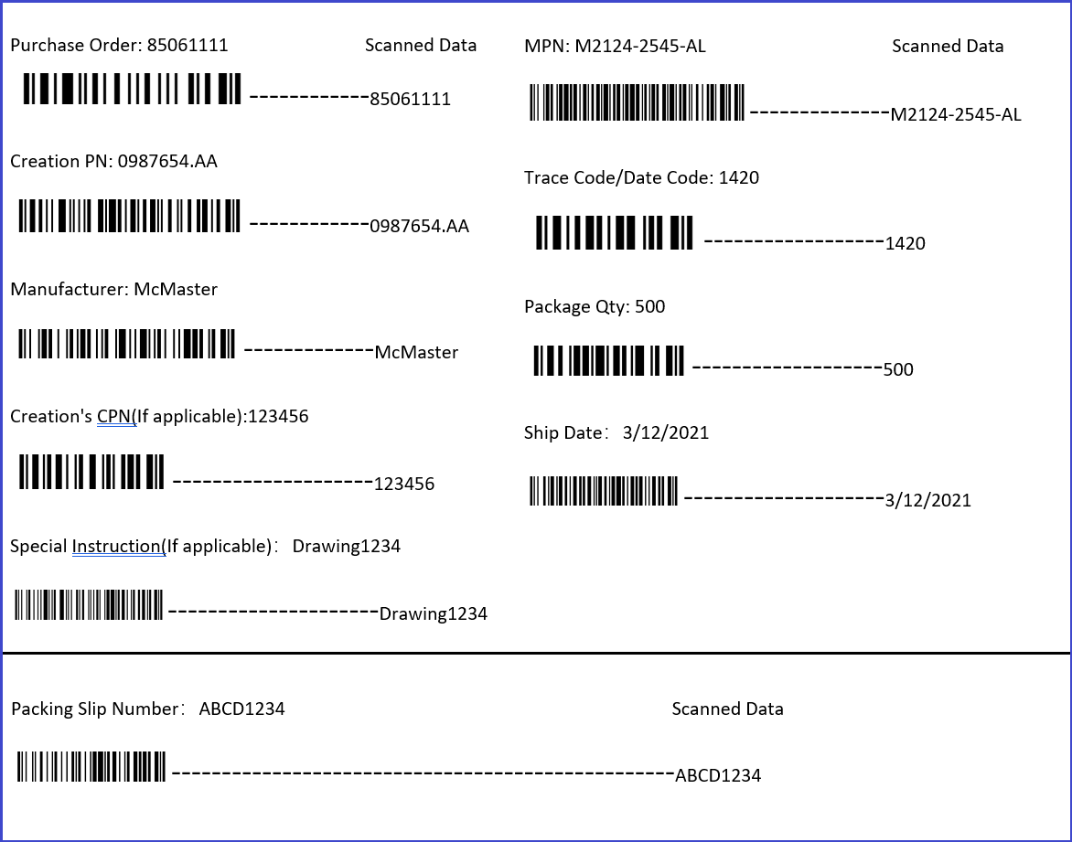

  - Barcode requirement
Regardless of the label shape and size, content must be included as both barcode and human readable font.
Bar code Characteristics
- Code 39 shall be used for bar codes
- Width of the narrow line shall not be less than 0.0066 inches (0.167mm)
- Ratio of Wide bar width to Narrow bar width shall be minimum of 2.5
- Bar Code height shall be minimum 0.20 Inches (5.08mm)
- Quiet Zones before and after each bar code shall be minimum of 0.25 Inch (6.35mm)

  - The package label shall be placed on the outer most level of box/pallet which contains the components.
  - Applied such that it does not interfere with any original manufacturer label.
  - Location
Two duplicated package labels shall be place in adjoined corner of the box as shown. At least one of the labels placed out face of the pallet.
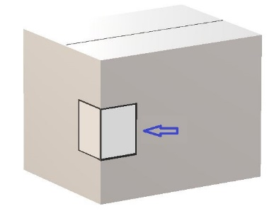
Two duplicated package labels shall be place in adjoined corner of the pallet as shown.
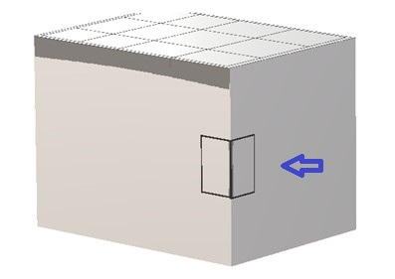

  - Duplicate labels
For parts where a label cannot be applied to the final carrier such as Moisture sensitive Package. There shall be duplicate labels placed on the immediate packaging (ESD bag/Moisture proof bag, box, etc.). One of the two labels shall be peelable or remove to facilitate label application after opening of the package. If the label cannot be applied due to space, it can be applied to the next higher-level packaging (i.e. box, bag).
  - Sample Label
For samples, another sample identification label must be pasted next to the "material identification label". Samples can be packed in the same box as partial package of large goods, but they must be clearly marked on the outer package (partial package, sample label).
  - Rework Label
For reworked products, another ‘reworked products’ identification label must be pasted next to the ‘material identification label’. The reworked products can not be packed in the same box with the new products, must be packed and identified separately.
  - Partial Package Label
Only one partial package is allowed for each material number of the same batch of delivered materials, and the quantity and ‘partial’ label must be marked on the packaging box.
  - Serialized traceability
Components that require serialized traceability, the traceability label must contain the serial number in barcode form and human readable font.
  - Regulatory label
Where applicable, any regulatory and safety markings shall be applied to the component. This includes RoHS, UL, CCC, WEEE, Danger, Warning or similar labels.

- SAFETY
NA
- RISKS aND OPPORTUNITIES
Without a supplier label requirement, there will be no consistency or standardization in the message or requirement we are sending to our suppliers.
- EXCEPTION AND Deviation
If any of the requirements of this procedure cannot be implemented in a timely manner or it needs to be delayed from its schedule or if they are skipped or changed for a reason; complete the Process Deviation Form and obtain approval from the functional Leader.
Deviation from this procedure leading to a nonconforming situation will be documented through internal Nonconformance database.

- Referenced Documents
NA
- Keywords
NA

